**Name: Session:**

**Programming II**

**Lab Exercise 5/24/2022**

When you complete each of these applications, print out your source code and a screenshot of your running application.

1. Create a Draw House application that allows the user to select the color of the sky, sun, roof, house, and door to draw in a label by clicking radio buttons. The application interface should look like:

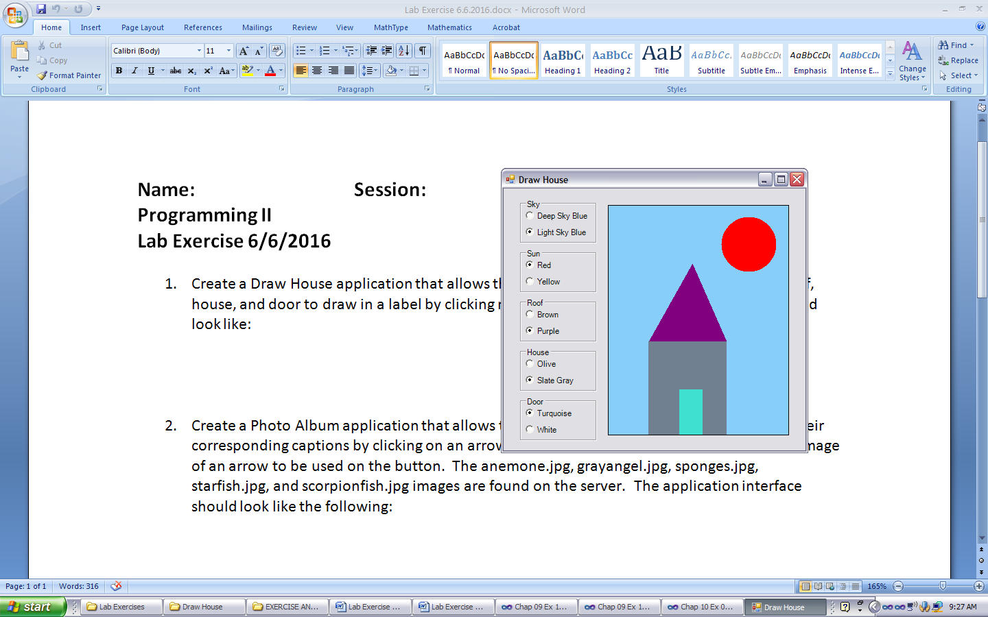

1. Create a Photo Album application that allows the user to scroll through photographs and their corresponding captions by clicking on an arrow button. Use the Image Editor to create an image of an arrow to be used on the button. The anemone.jpg, grayangel.jpg, sponges.jpg, starfish.jpg, and scorpionfish.jpg images are found on the server. The application interface should look like the following:

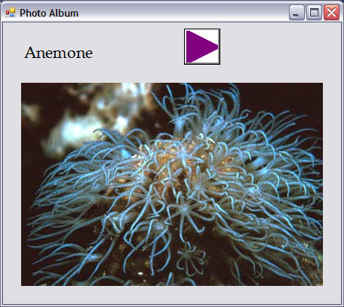

1. Create a Bird Flying application that simulates a flying bird. Use the bird1.gif, bird2.gif, and bird3.gif images that are found on the server. The three different animations should look similar to:

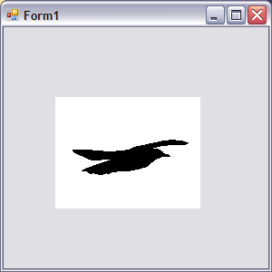

1. Create a Turtle Run application that allows the user to control the speed of the animation by clicking a button. Use turtle1.bmp, turtle2.bmp, and turtle3.bmp images that are found on the server. The background of the form should be white and the background color of the buttons should be MediumSeaGreen. The application interface should look similar to:

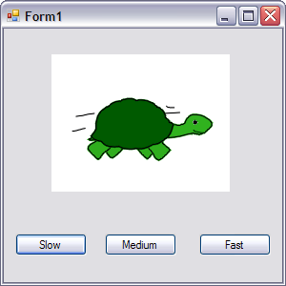

1. Create a Face application that displays a happy face then Happy is clicked and a sad face when Sad is clicked. Use a PictureBox and the FillRectangle, FillEllipse, and FillPie methods with different brush colors. The interface should look like:

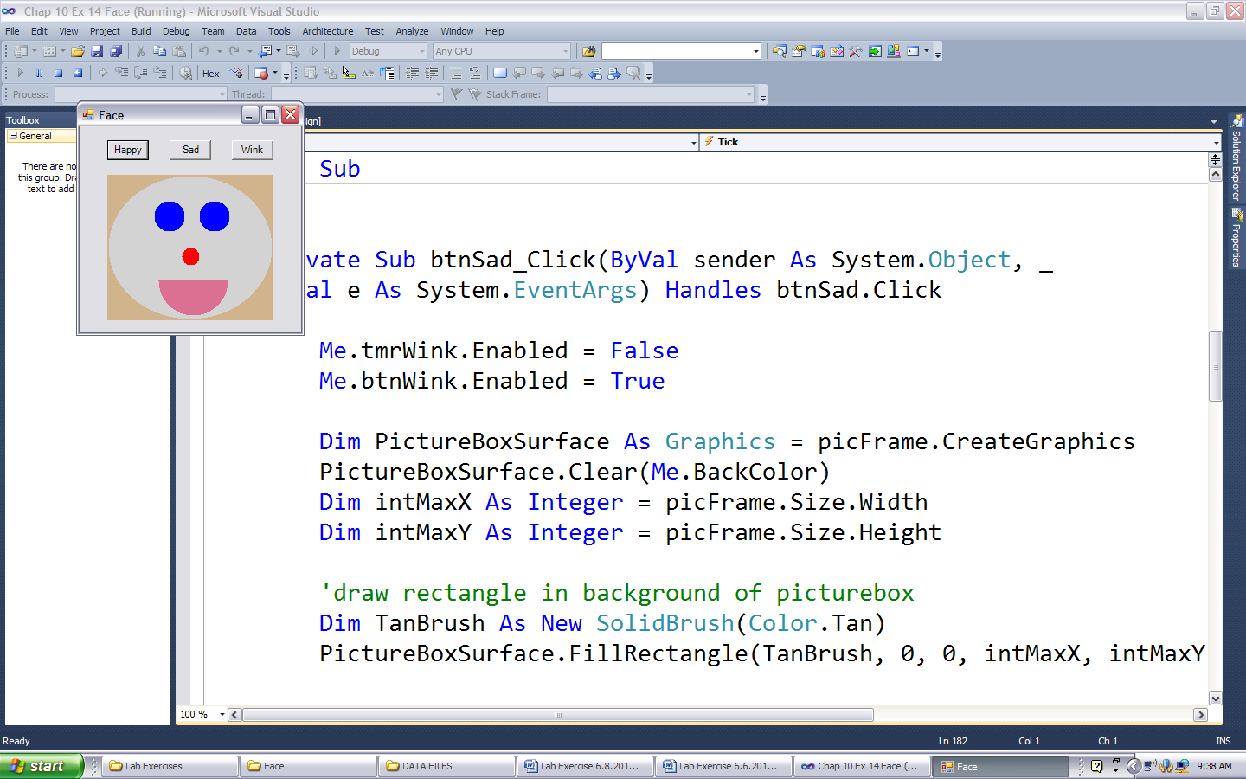

1. Create a Pie Chart application that allows the user to enter 4 values to represent relative pie slices in a pie chart. The percentage of the total that each value represents and a pie chart drawing with different color pie slices should be displayed when the Chart button is clicked. Hint: Use the percentage of the total values to determine the degree each pie slice will sweep out of 360 degrees. Your application interface should look similar to:

